Food Recognition and Calorie Estimation using AI

In this project we are employing CNN2D algorithm for food recognition and then estimating calorie from recognized food. In a day average person has to consume 2500 calorie and what food user consume will be tracked by the application and then display output as ‘Available calorie in recognized food, total calorie consumed in a day and pending calorie’. If pending calorie value goes in NEGATIVE will indicate user about total calorie already consumed.

To train CNN2D algorithm we have utilized Food11 dataset which contains images of daily taking foods and calories and in below screen showing dataset different food details

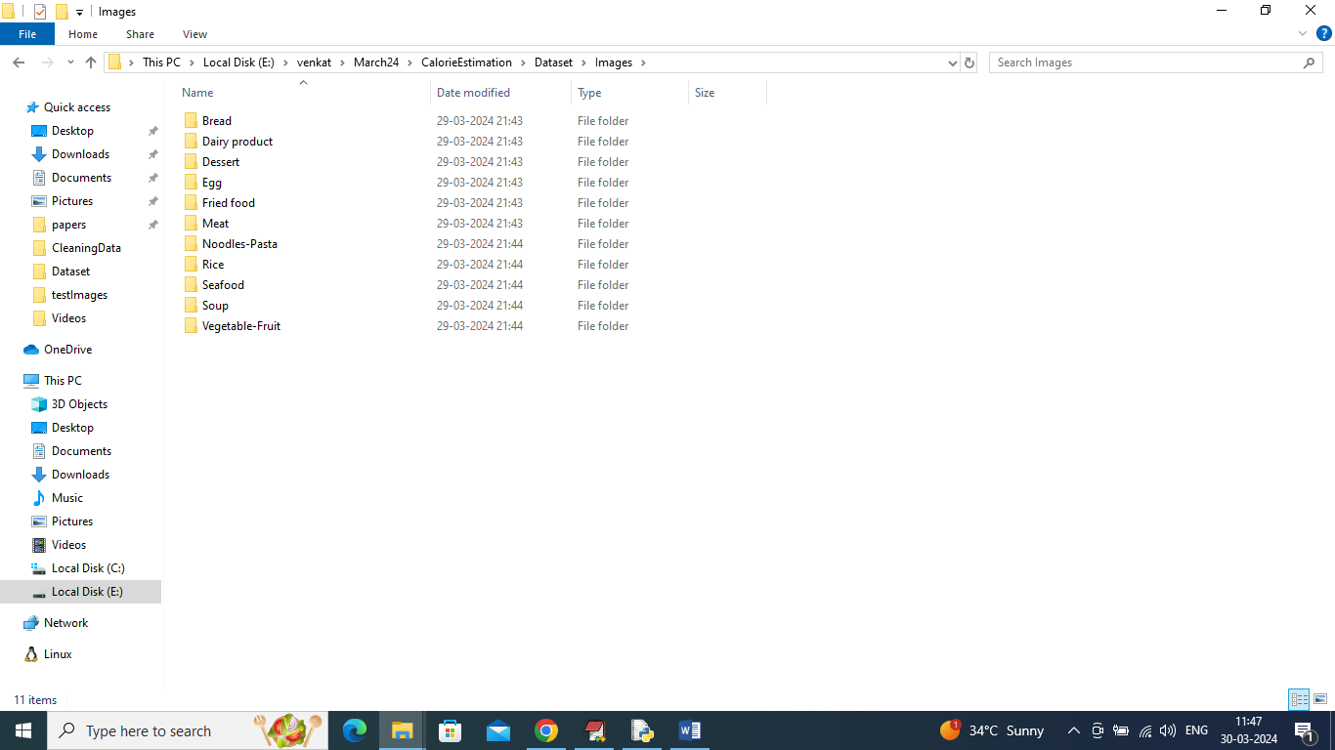

In above screen we have 11 different folders and each folder contains related images and by using above dataset will train and test CNN algorithm performance. Algorithm is evaluated in terms of accuracy, precision, recall, confusion matrix graph and FSCORE.

To implement this project we have designed following modules

1. Upload Food Dataset: using this module will upload dataset to application and then application will read all images and visualize graph of different food images loaded
2. Pre-process Dataset: will perform image processing techniques like shuffling, normalization and resizing to equal size
3. Split Dataset Train & Test: split dataset images into train and test using a ratio of 80:20 where 80% images for training and 20% for testing
4. Train AI on Food Dataset: 80% training images will be input to CNN algorithm to train a model and this model will be applied on 20% test data to calculate prediction accuracy
5. Food Recognition & Calorie Estimation: using this module will upload test image and then application will recognized food type and estimate calorie

SCREEN SHOTS

To run project double click on run.bat file to get below screen

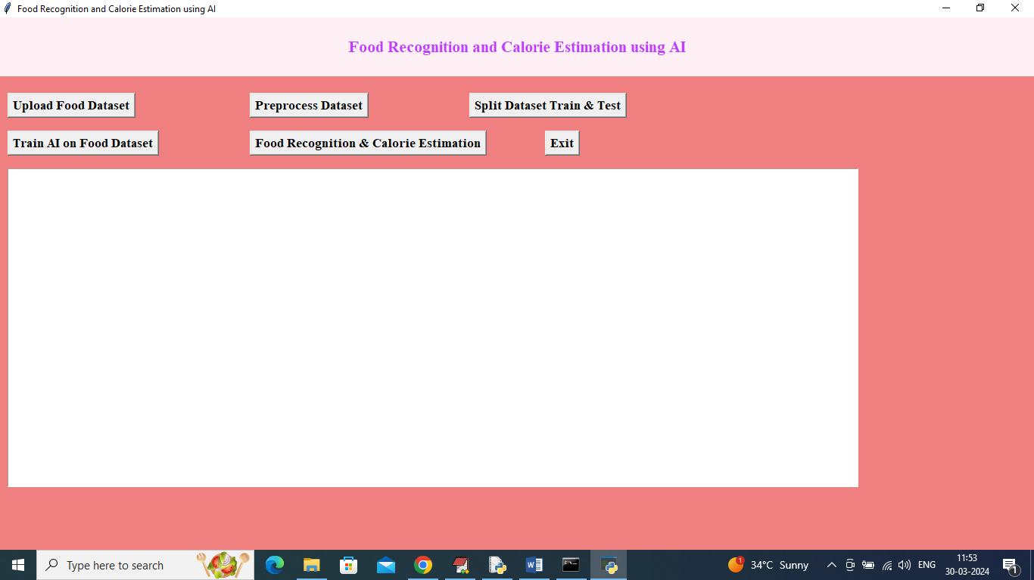

In above screen click on ‘Upload Food Dataset’ button to upload dataset and get below page

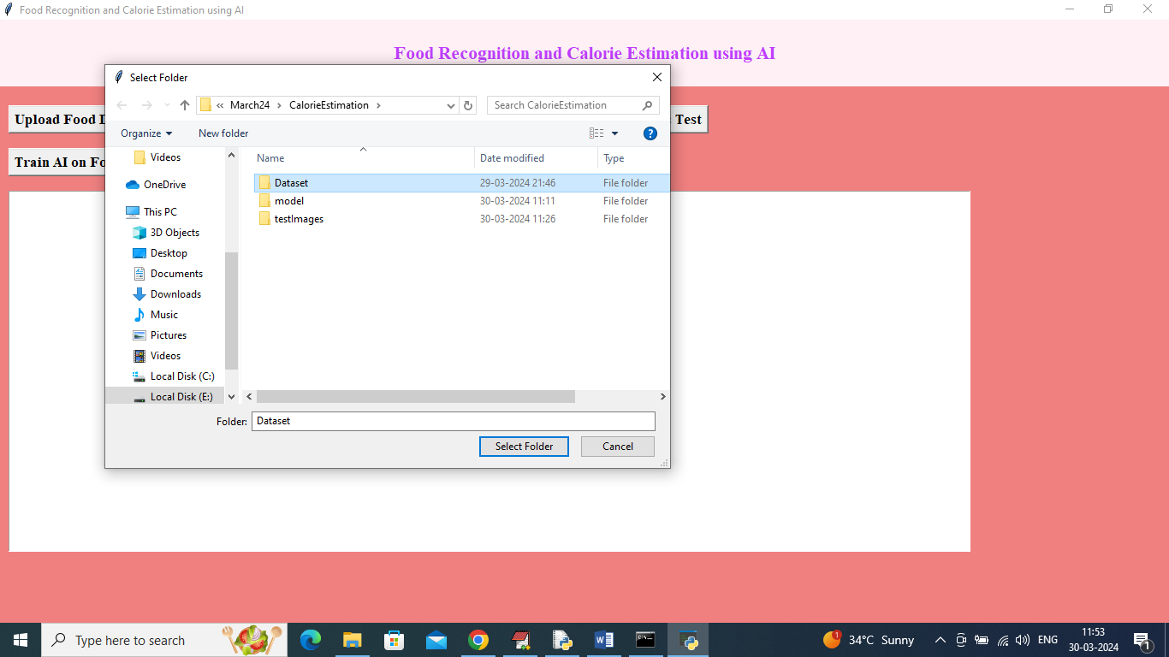

In above screen selecting and uploading ‘dataset’ folder and then click on ‘Select Folder’ button to load dataset and get below page

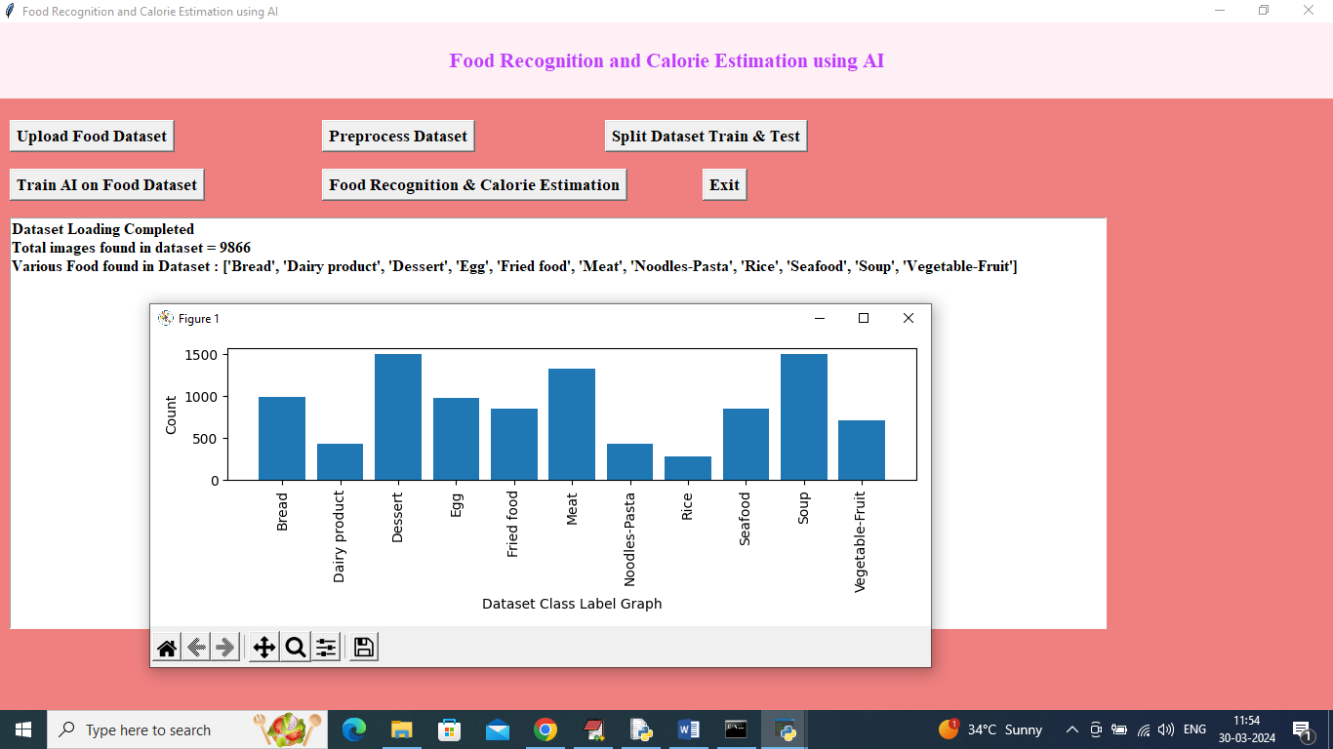

In above screen can see dataset loaded and can see different food available in dataset and in graph x-axis represents ‘Food Type’ and y-axis represents number of images found in that food category and now click on ‘Pre-process Images’ link to normalize images and get below output

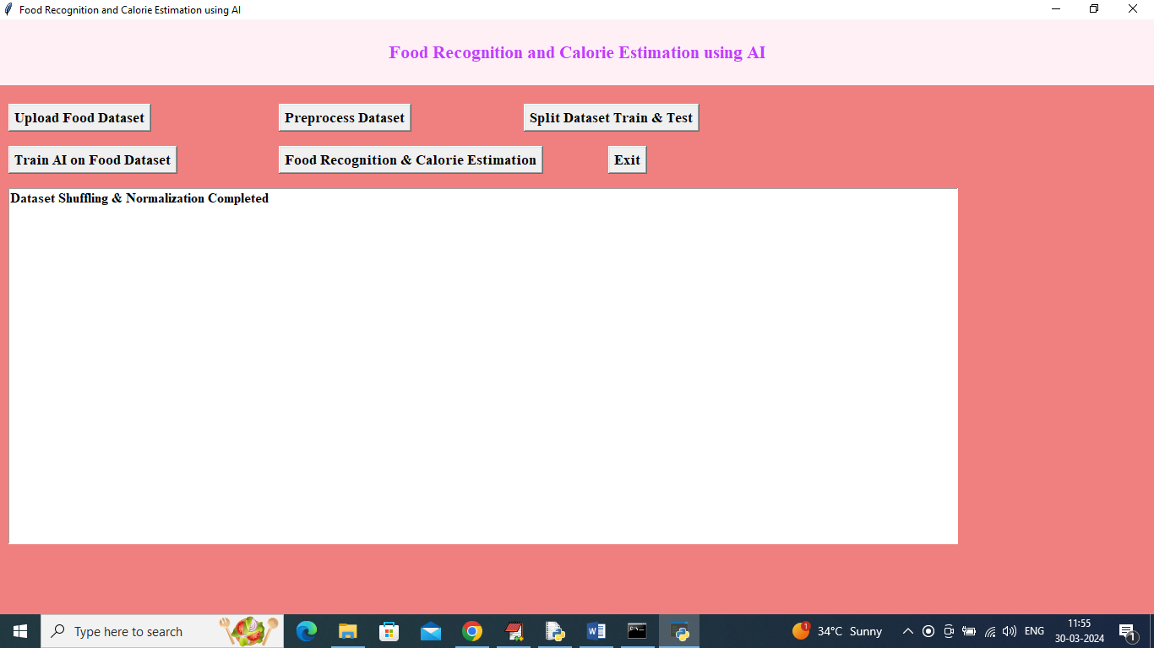

In above screen images are processed and now click on ‘Split Dataset Train & Test’ button to split dataset into train and test and then will get below output

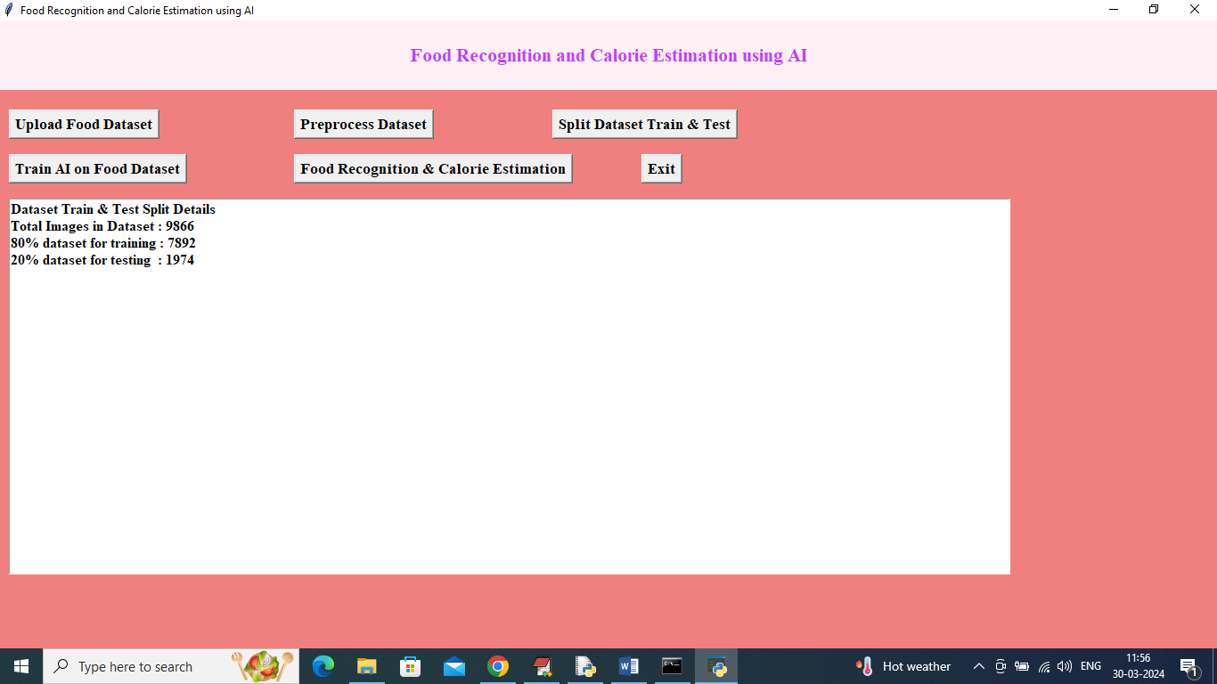

In above screen can see total images and 80% images size for training and 20% for testing and now click on ‘Train AI on Food Dataset’ button to train algorithm and then will get below output

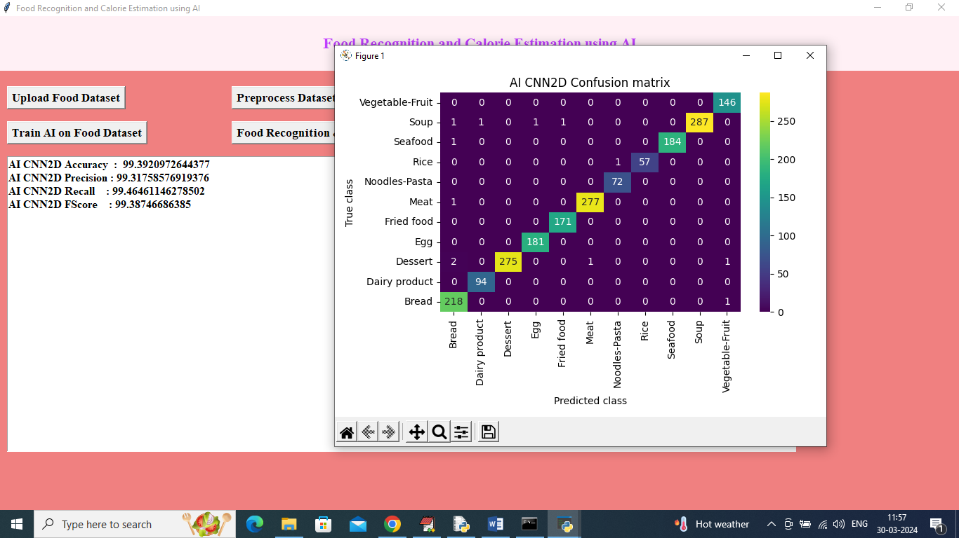

In above screen CNN2D training completed and it got an accuracy off 99% and can see other metrics like precision, recall and FSCORE. In confusion matrix graph x-axis represents Predicted Labels and y-axis represents True Labels and all different colour boxes in diagnol represents correct prediction count and remaining blue boxes represents incorrect prediction count which are very few. Now click on ‘Food Recognition & Calorie Estimation’ button to upload test image and get below output

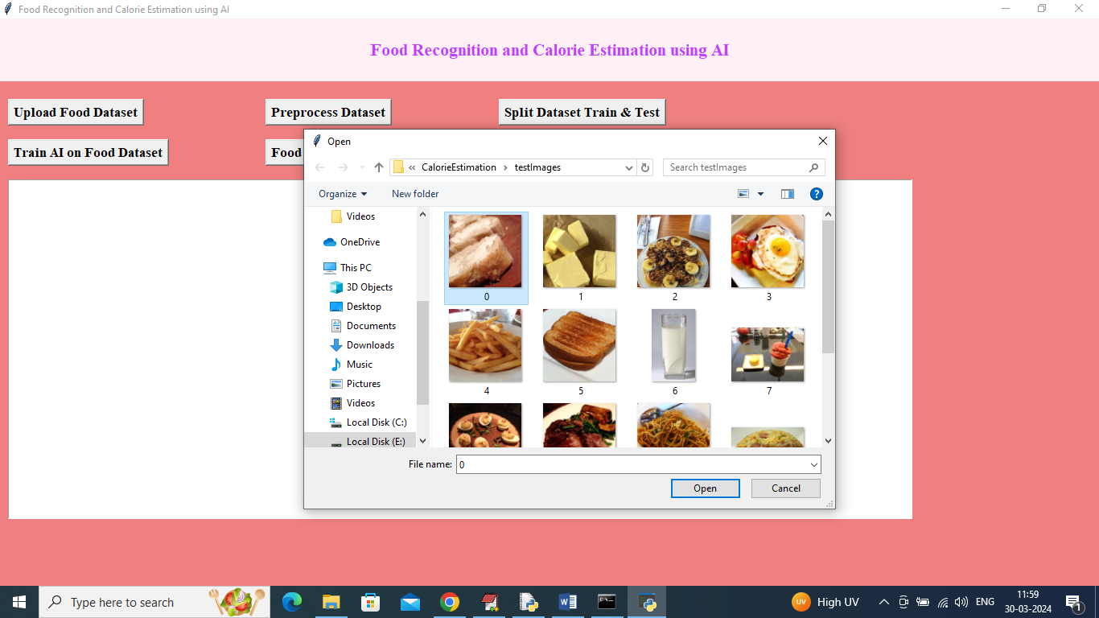

In above screen selecting and uploading 0.jpg and then click on ‘Open’ button to get below output

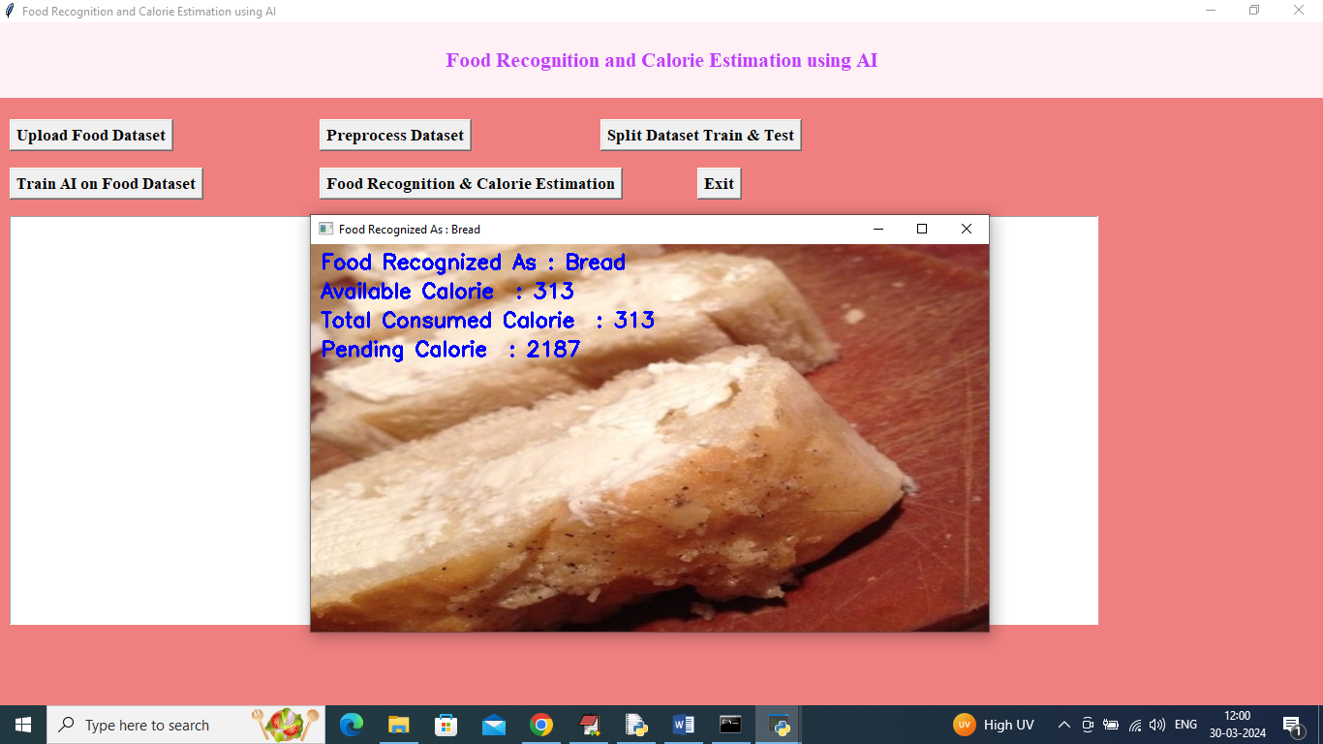

In above screen food recognized as ‘Bread’ and can see available calorie and consumed calorie and the pending calorie to be taken and now upload another image so will get pending and consume updated calorie

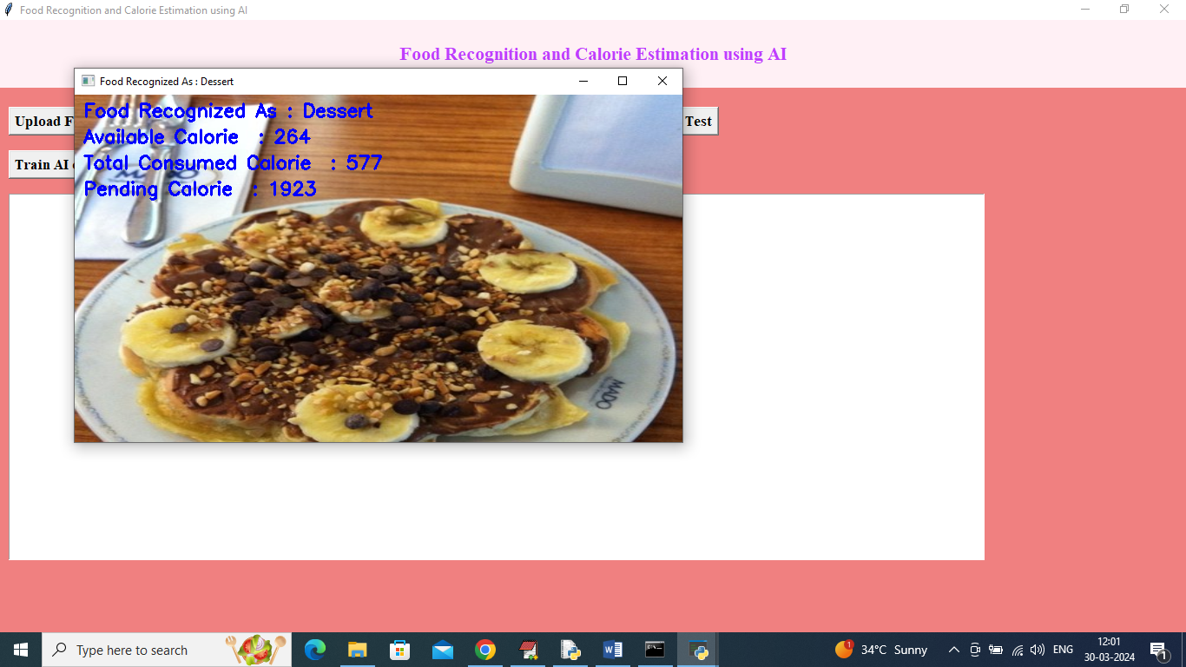

In above screen food recognized as ‘Dessert’ and can updated calorie values

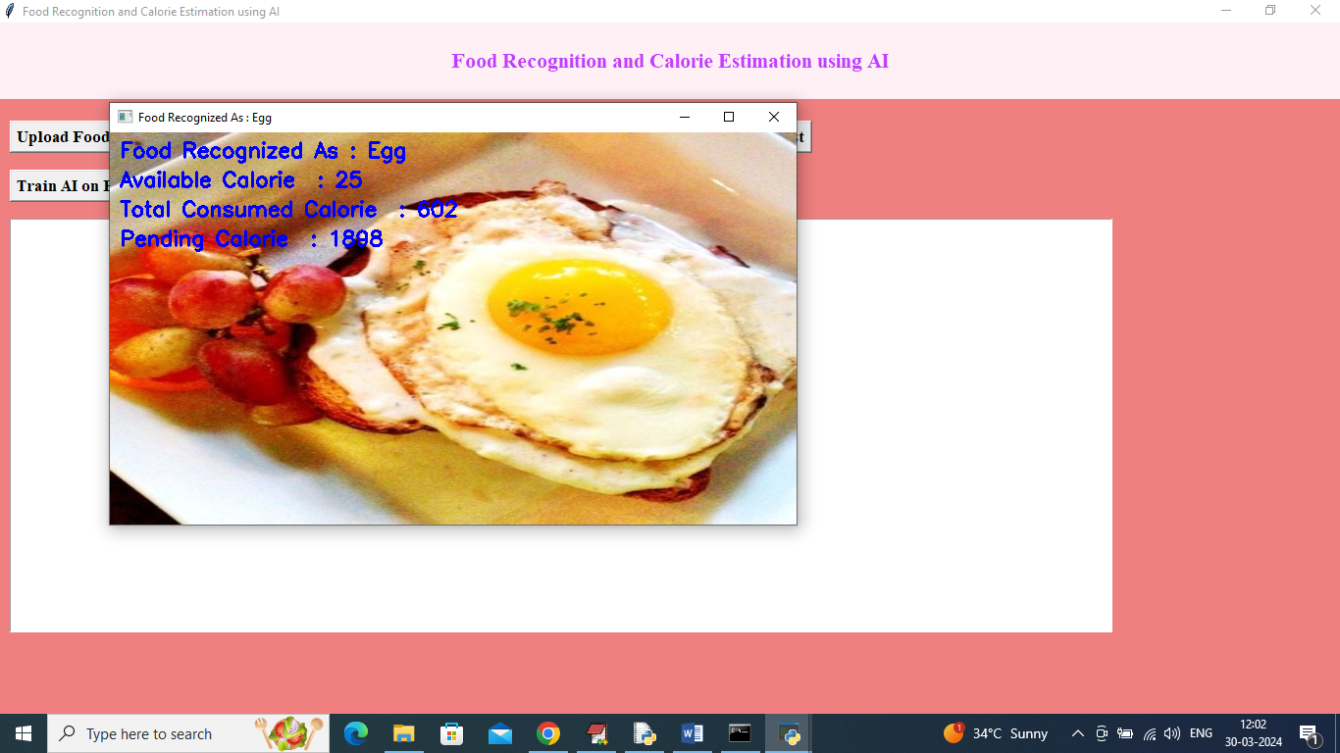

Above is recognized as ‘Egg’

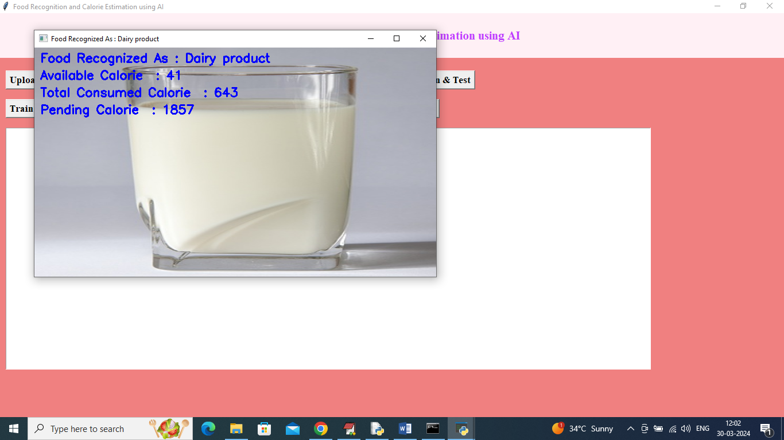

Above is recognized as dairy product

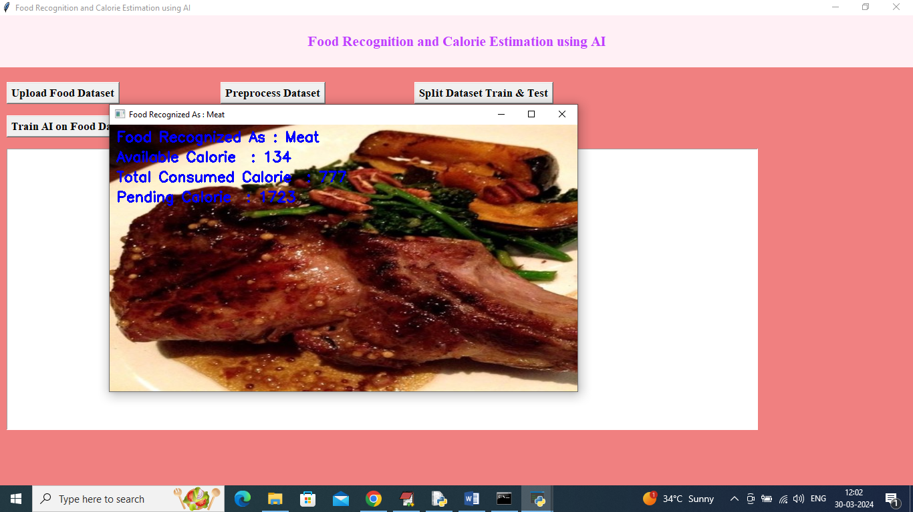

Above is recognized as Meat

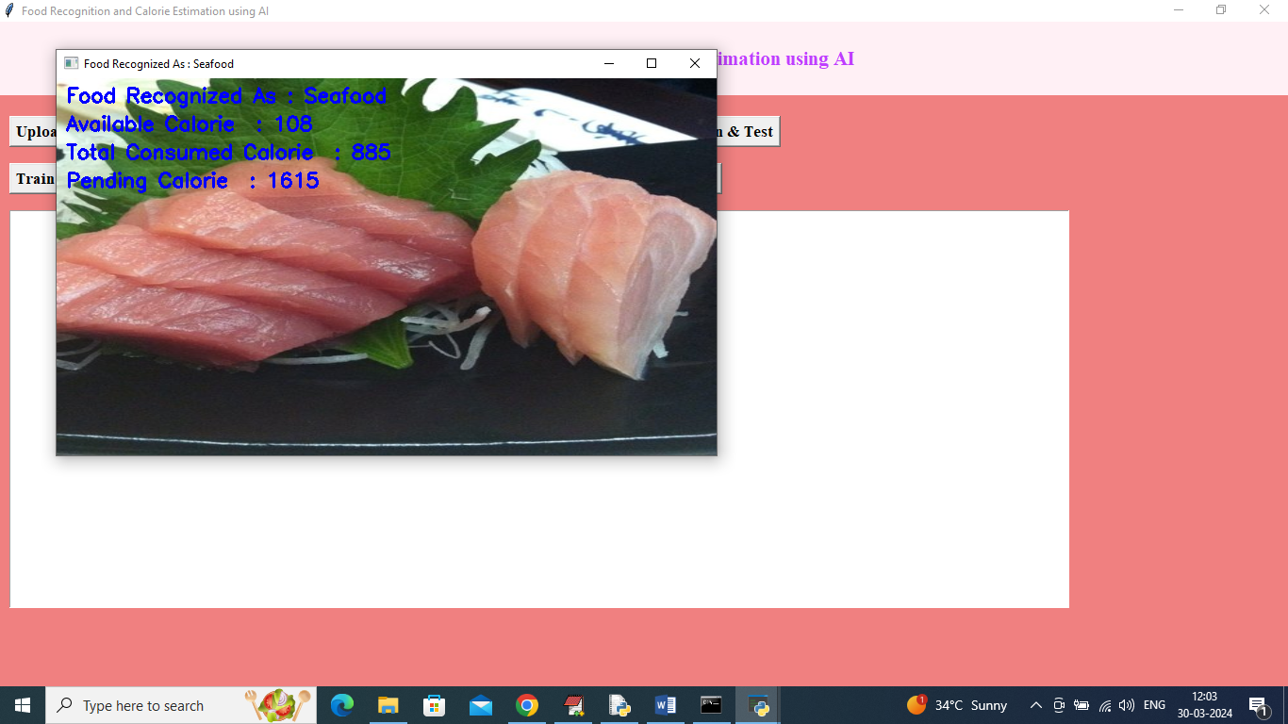

Above is recognized as Seafood

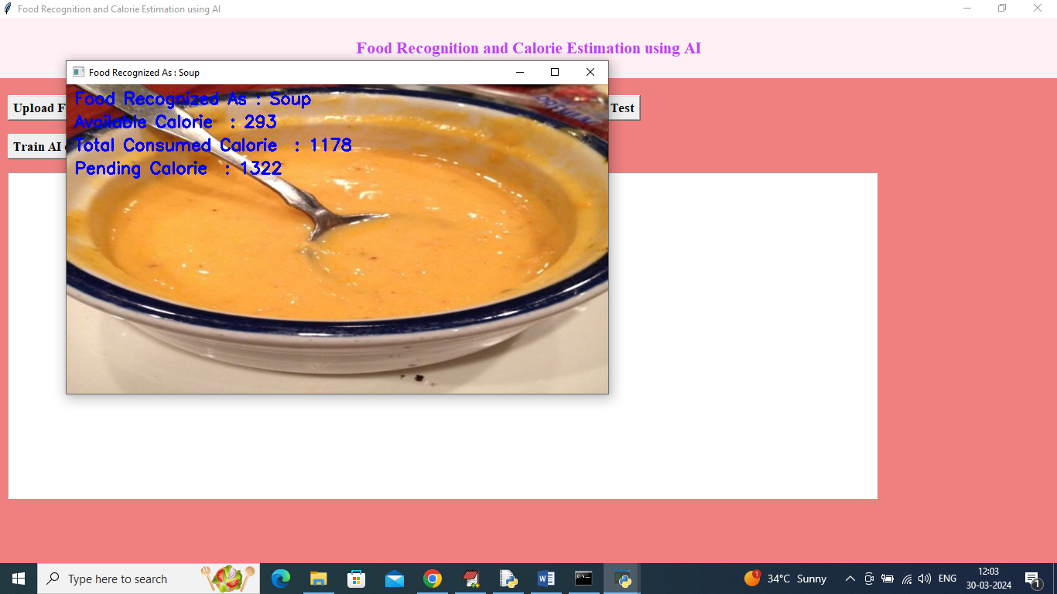

Above is recognized as soup